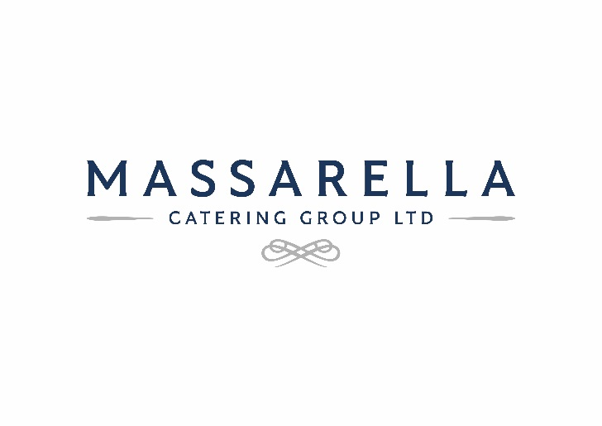

GENDER PAY GAP REPORT 2022

*Our Commitment to equality*

Our Family business is committed to being an employer of choice, with a guiding principle of an equitable and inclusive approach to pay and rewards. We are committed to equal pay and welcomed the introduction of gender pay gap reporting to encourage businesses to review and develop their process for ensuring equality.

Within our main subsidiary businesses of Massarella Restaurants Ltd we are committed to working towards achieving a 50:50 gender balance (within a 10% tolerance) throughout this business and we are pleased to report that we have shown improvements in 2022 from our initial report in 2017. Unfortunately, due to the challenging business climate following the Covid-19 pandemic and decline in our business during this time no bonuses were paid during this financial year and therefore no figures were given in our Gender pay report on this.

**What is Gender Pay Gap?**

A gender pay gap is a measure of the difference in average pay of men and women across the business. It’s different to equal pay comparison which would involve direct comparison of two people or groups of people carrying out the same work.

Businesses are required to report on six different gender pay figures:

1. **The mean:** This is calculated by adding all female employees’ hourly rates of pay together and dividing by the total number of women and adding all male employees’ hourly rates of pay together and dividing by the total number of men. The calculation then requires us to show the difference between the mean hourly rate for men and the mean hourly rate for women.
2. **The median:** The median is the mid-point when the hourly rates of pay of all employees are ordered from highest to lowest. The median pay gap is then calculated as the difference between the median hourly rate for men and the median hourly rate for women.
3. **A breakdown of workforce earning distributed by quartile:** The lower quartile contains the 25% lowest hourly rates of pay and the upper quartile includes the highest hourly rates. This provides an overview of earning distribution between men and women across the company.

Our Gender Pay Performance

|  |  |  |
| --- | --- | --- |
|  | *MEAN*  *Gender Pay Gap* | *MEDIAN*  *Gender Pay Gap* |
| Massarella Restaurants Ltd | 4.6% | 0% |

Proportion of males and females in each pay quartile:

**Massarella Restaurants Ltd**

Gender pay differences can be down to several factors and does not necessarily mean that we have equal pay issues. Our analysis of comparable roles shows we reward men and women fairly for the same job. One of the main reasons for our gender pay gap is because a high proportion of our positions are part-time operational roles which attracts more female employees. Our current split of employees across our business is 80% women and 20% men.

As part of our Company Vision and Core Values we are committed to continually monitor and review our pay structure and evaluation of jobs to ensure we attract, reward, and pay fairly and equally across our business.

We can confirm that our data has been calculated according to the requirements of the Equality Act 2010.

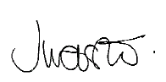

Jayne Webster

Human Resources Director